Silhouette metric for img015001.jpg is: 0.9840689247367167

Davies Bouldin metric for img015001.jpg is: 0.019999287880343802

Calinski Harabasz metric for img015001.jpg is: 1306750.834132018

ID 0: (135, 608)

ID 1: (1677, 736)

ID 2: (1543, 653)

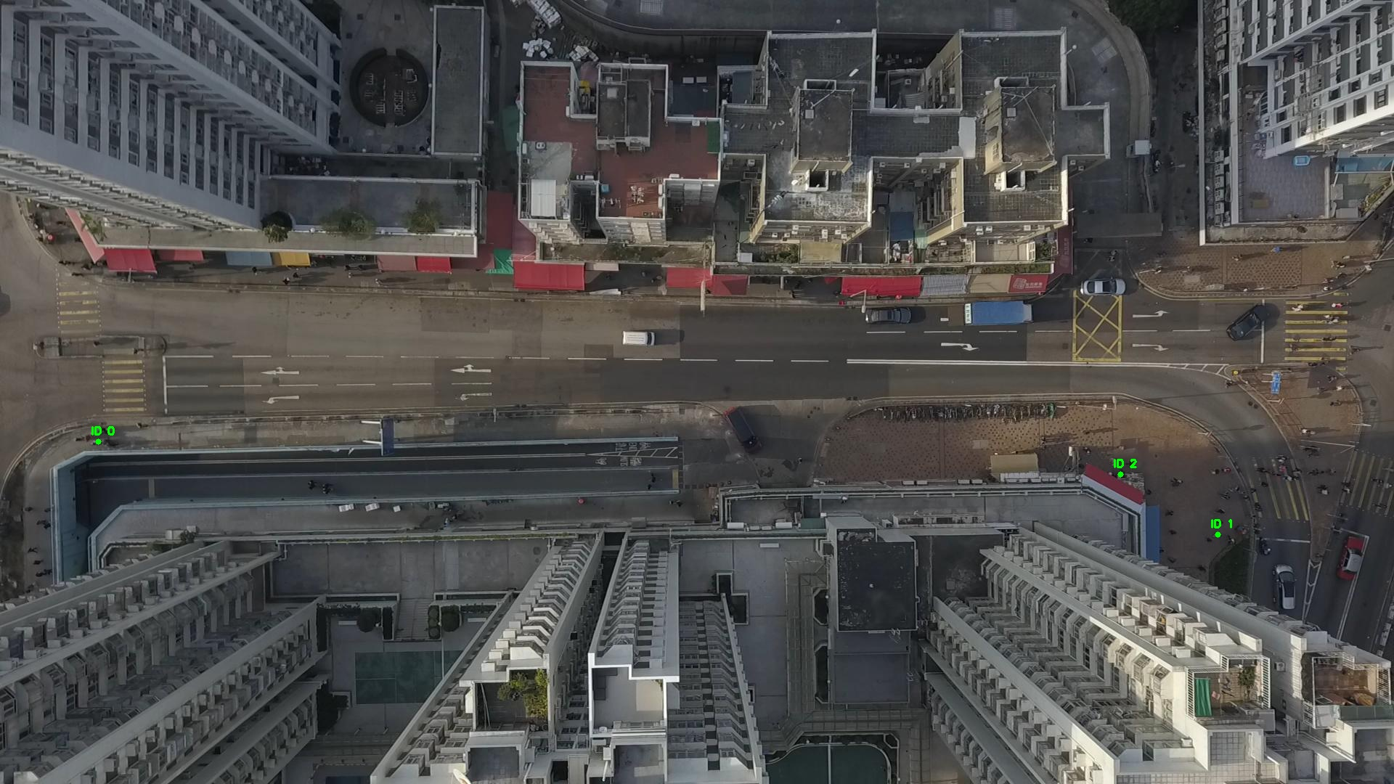

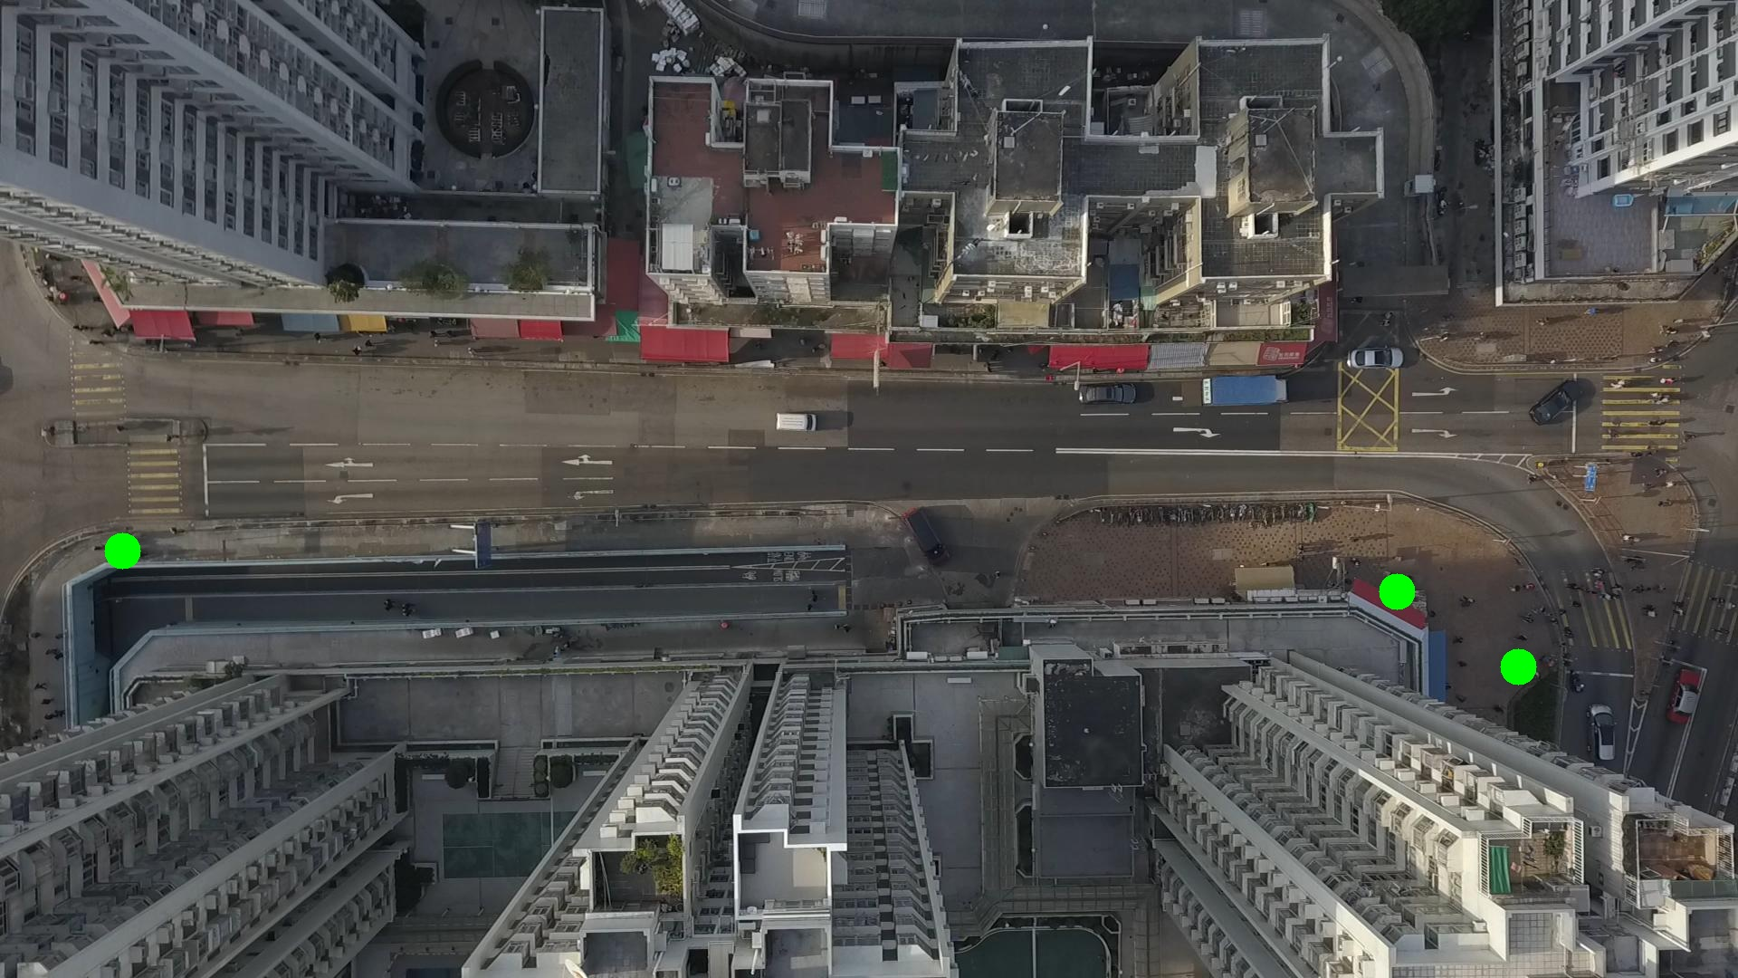

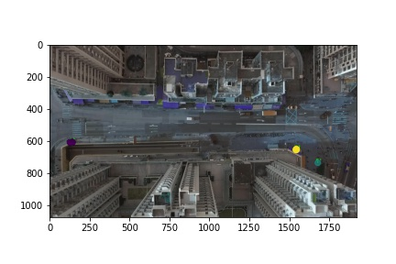

Silhouette metric for img015002.jpg is: 0.9869096599345946

Davies Bouldin metric for img015002.jpg is: 0.02462976384978885

Calinski Harabasz metric for img015002.jpg is: 2078929.677131519

ID 0: (133, 608)

ID 1: (1748, 652)

ID 2: (1543, 653)

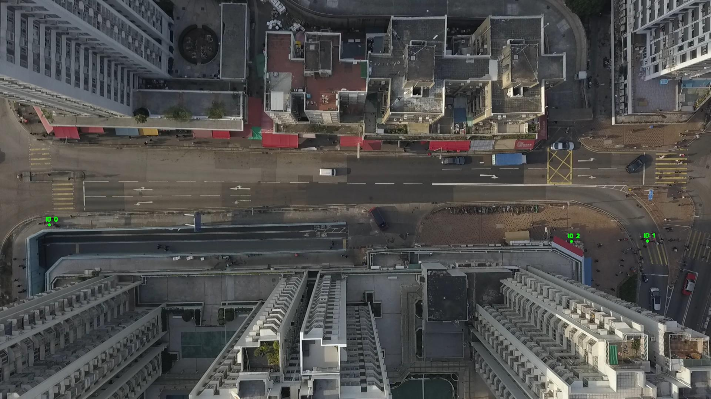

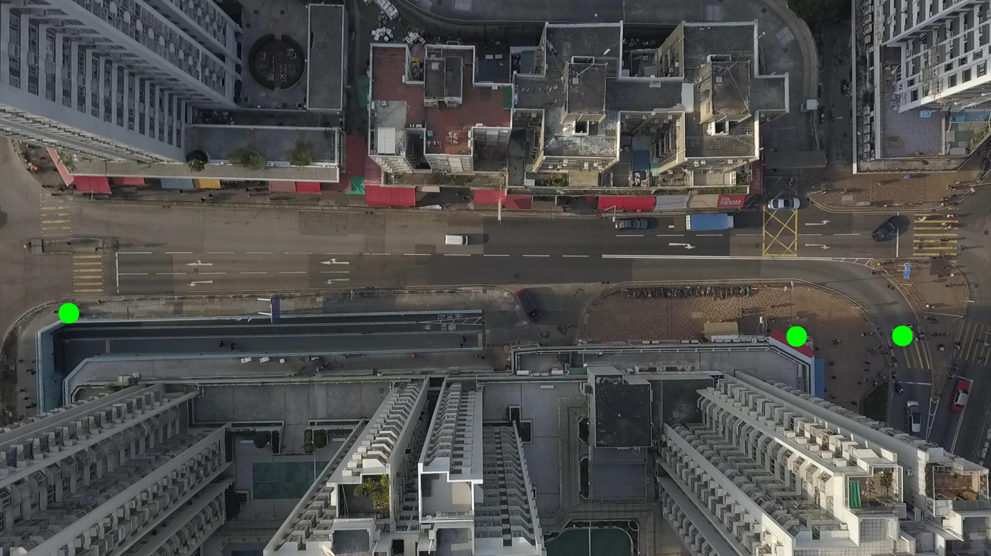

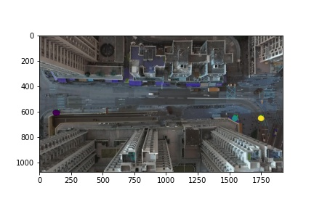

Silhouette metric for img015003.jpg is: 0.9741230114869673

Davies Bouldin metric for img015003.jpg is: 0.05193221348320524

Calinski Harabasz metric for img015003.jpg is: 313805.5632080784

ID 0: (138, 608)

ID 1: (1680, 734)

ID 2: (1543, 652)

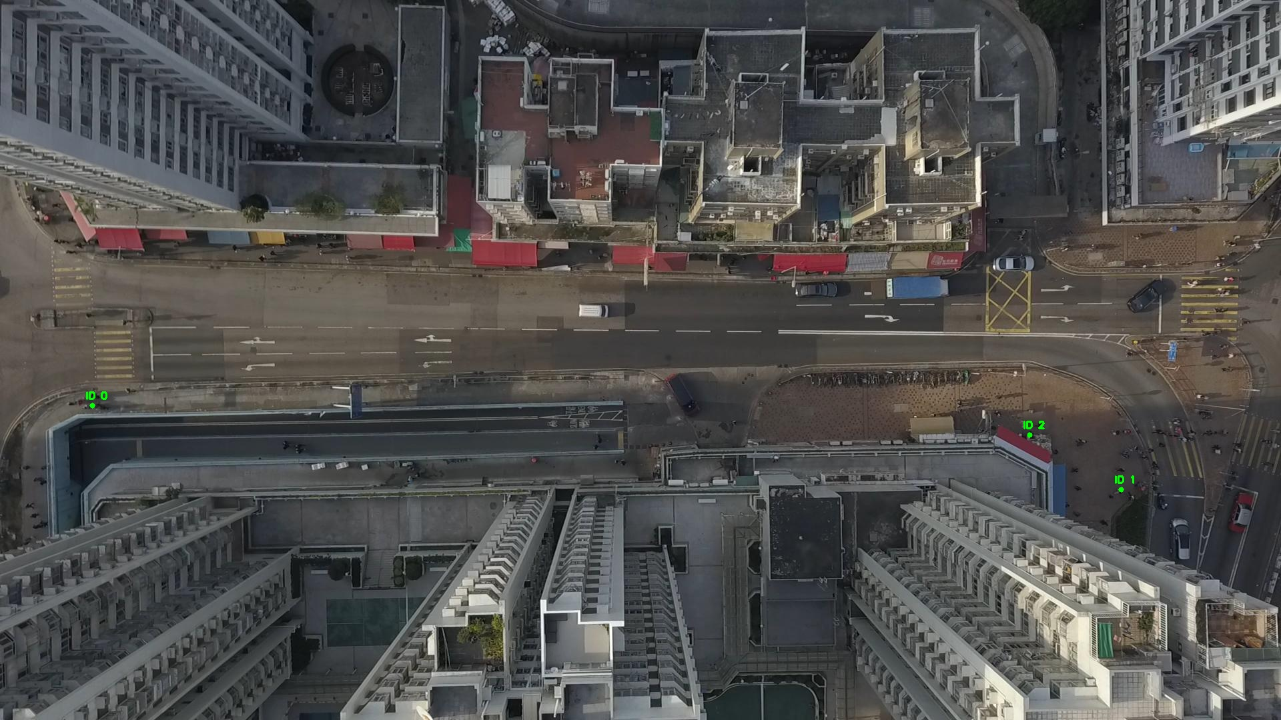

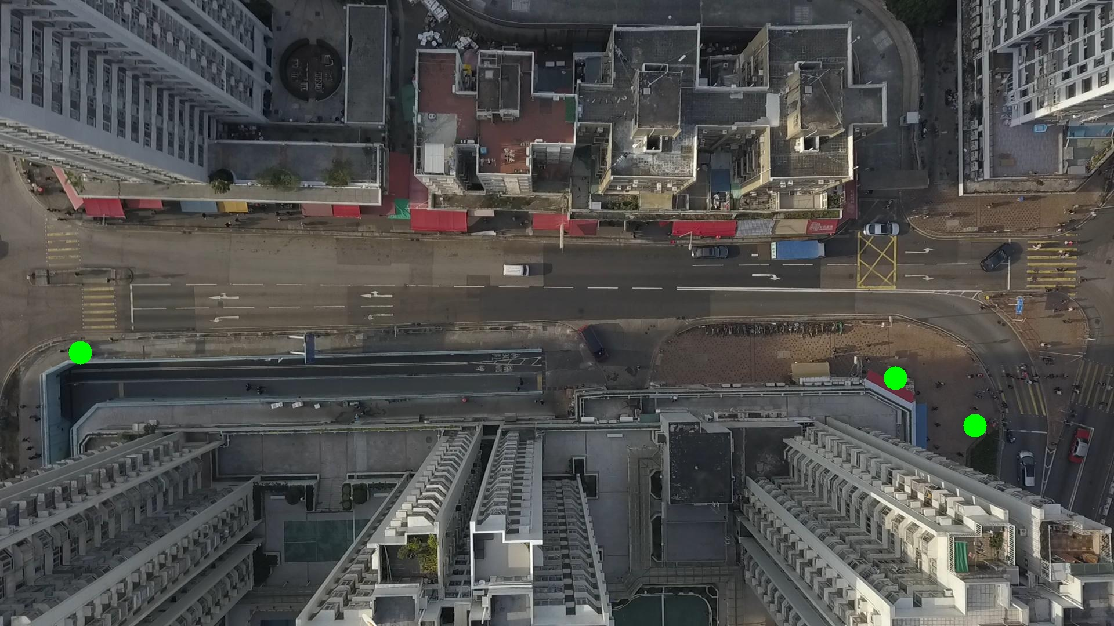

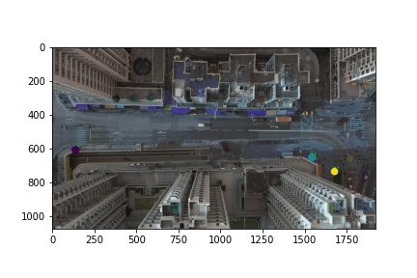

Silhouette metric for img015004.jpg is: 0.9975136921506035

Davies Bouldin metric for img015004.jpg is: 0.0033643952430236616

Calinski Harabasz metric for img015004.jpg is: 4594034.734868993

ID 0: (138, 608)

ID 1: (1680, 734)

ID 2: (1544, 653)

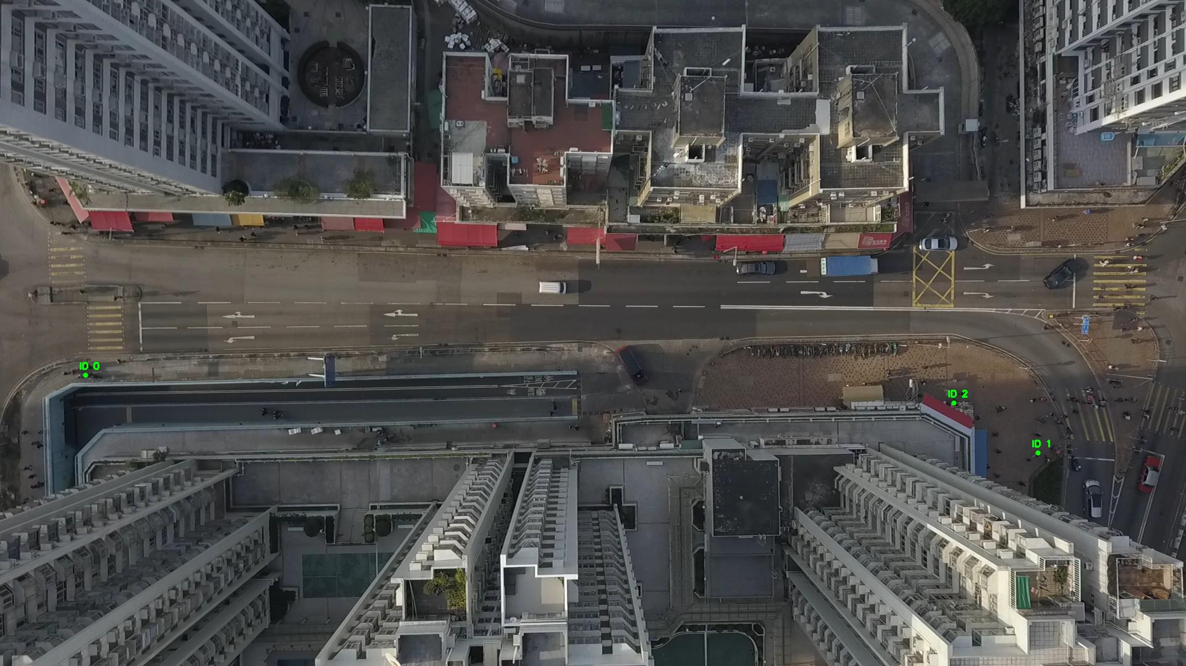

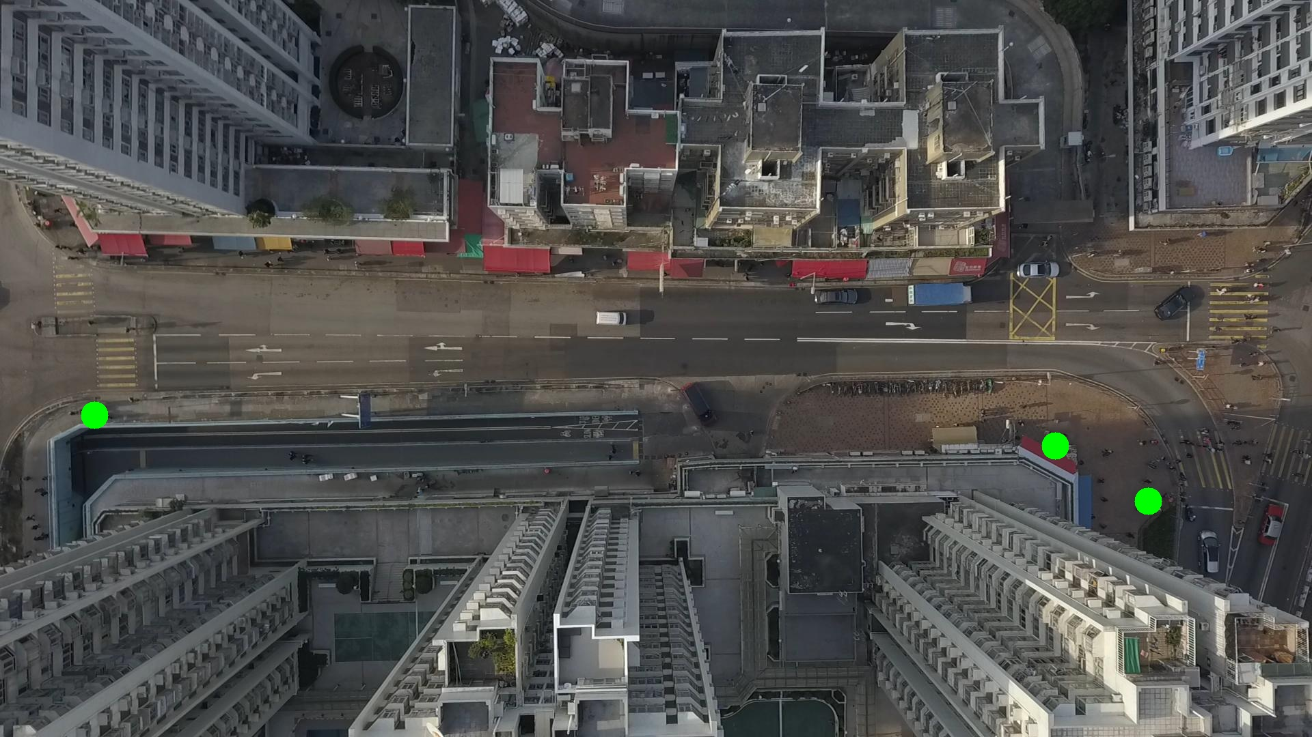

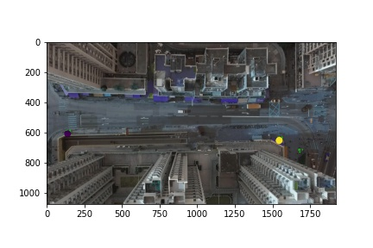

Silhouette metric for img015005.jpg is: 0.9970179859082143

Davies Bouldin metric for img015005.jpg is: 0.006210885577198835

Calinski Harabasz metric for img015005.jpg is: 999555.5526432139

ID 0: (132, 609)

ID 1: (1680, 734)

ID 2: (1544, 652)

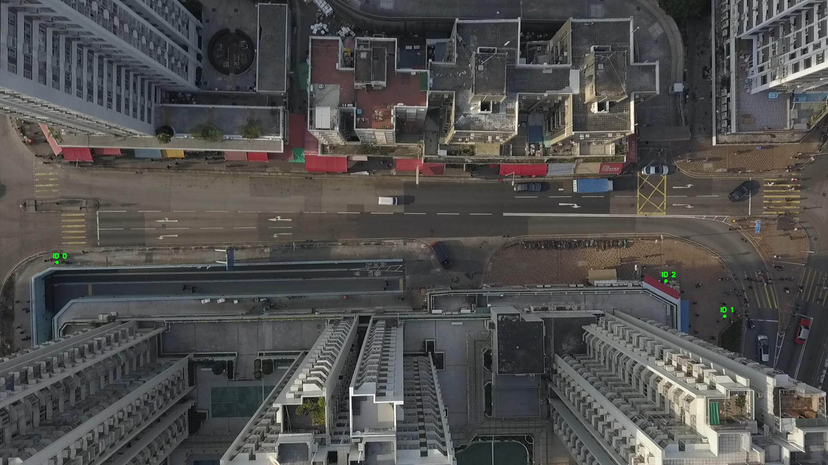

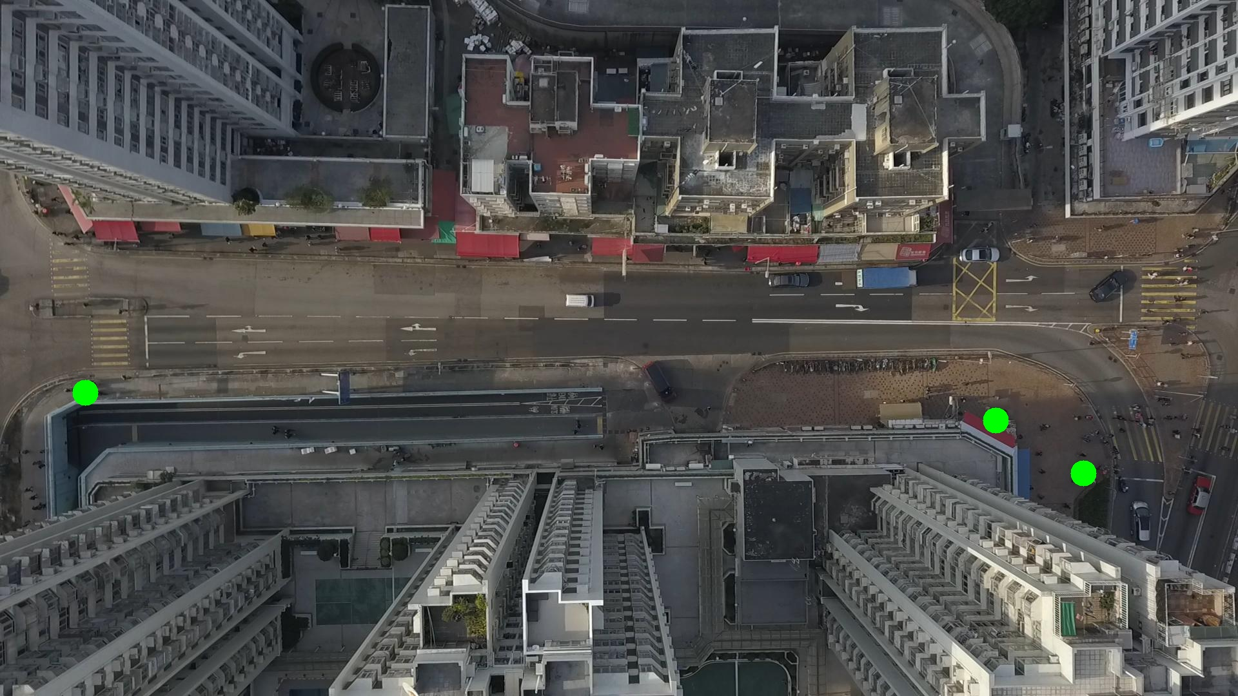

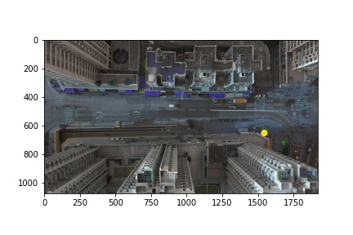

Silhouette metric for img015006.jpg is: 0.9902681856475356

Davies Bouldin metric for img015006.jpg is: 0.0160703586959929

Calinski Harabasz metric for img015006.jpg is: 78581.27094505589

ID 0: (129, 616)

ID 1: (1680, 734)

ID 2: (1544, 653)

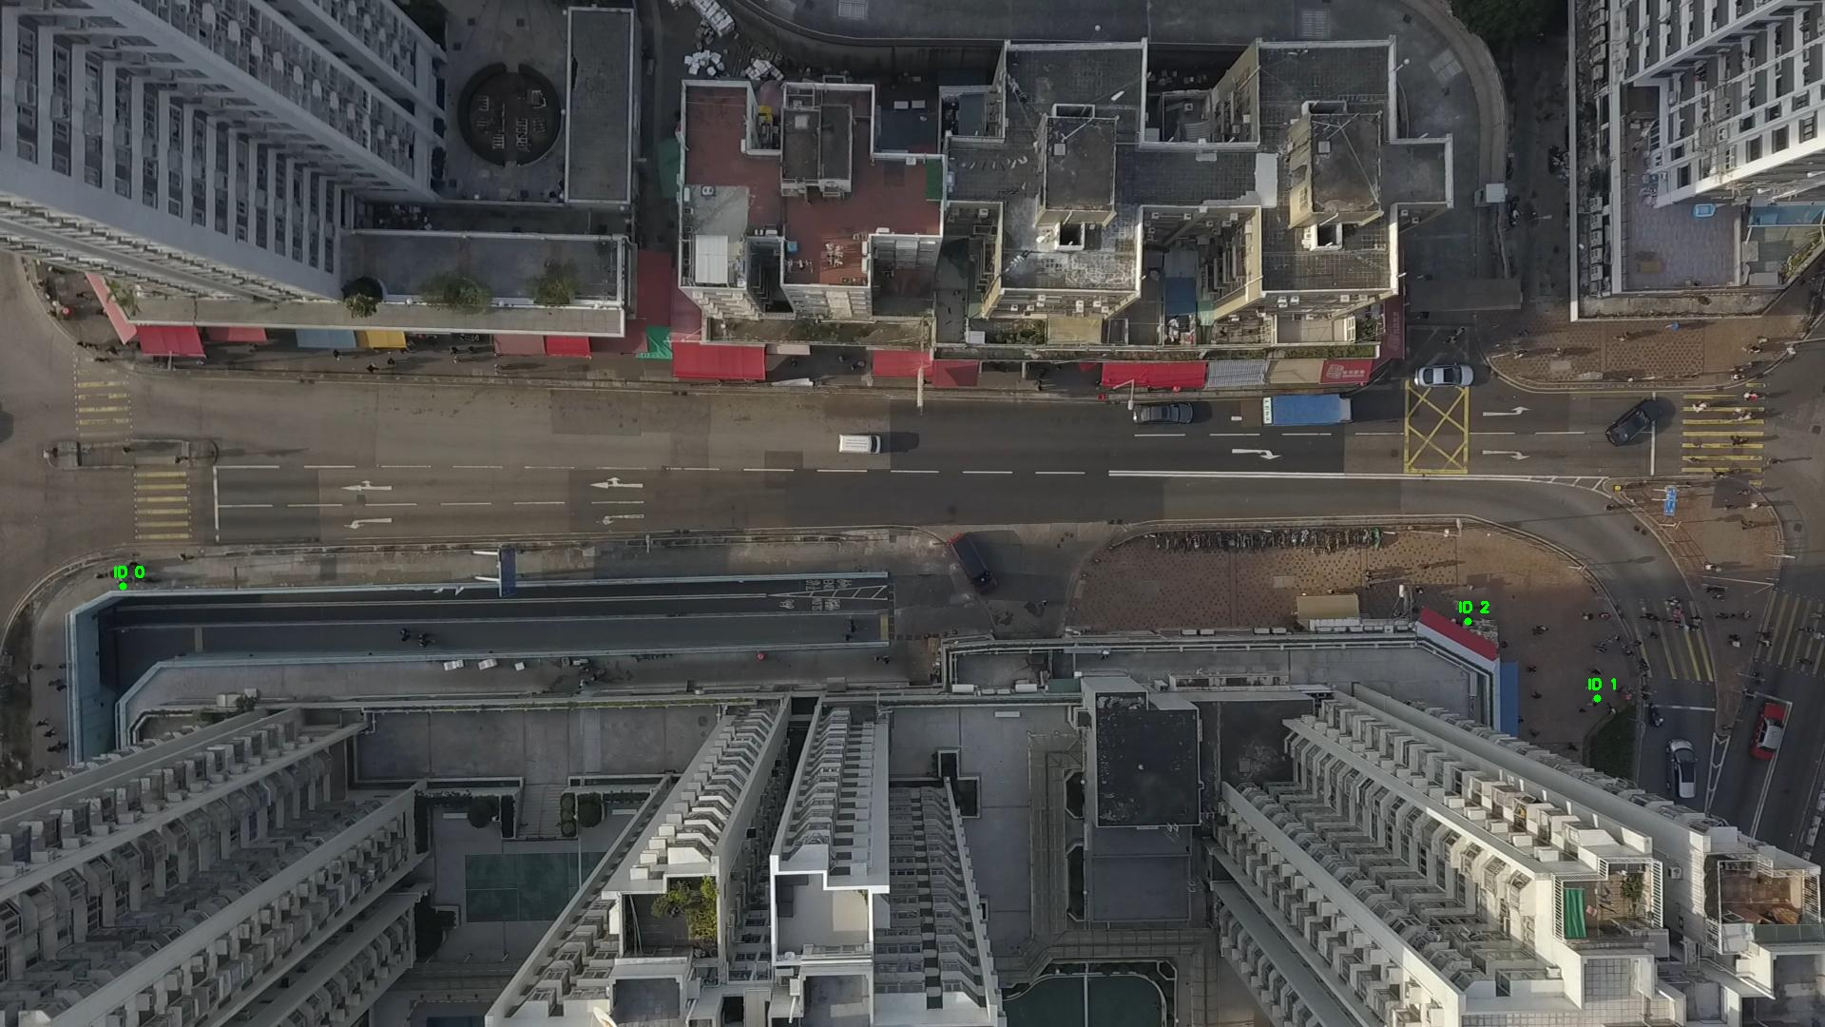

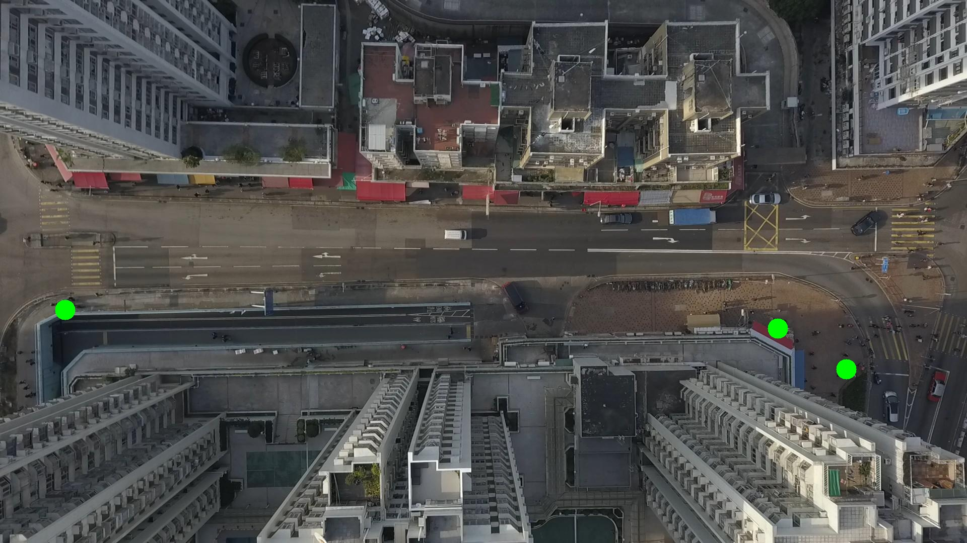

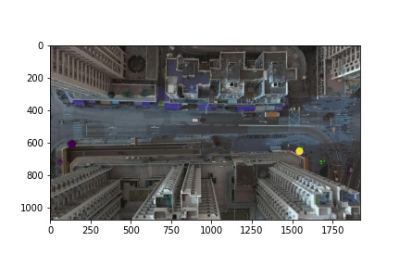

Silhouette metric for img015007.jpg is: 0.9971411184347619

Davies Bouldin metric for img015007.jpg is: 0.004088574795101264

Calinski Harabasz metric for img015007.jpg is: 2847947.0209108973

ID 0: (135, 608)

ID 1: (1680, 734)

ID 2: (1544, 652)

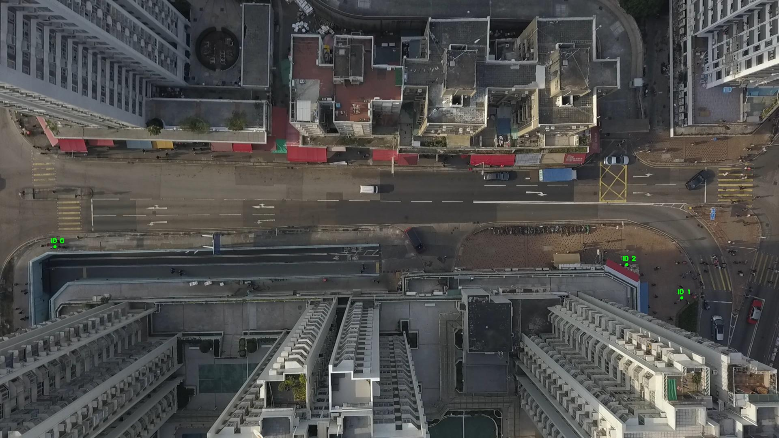

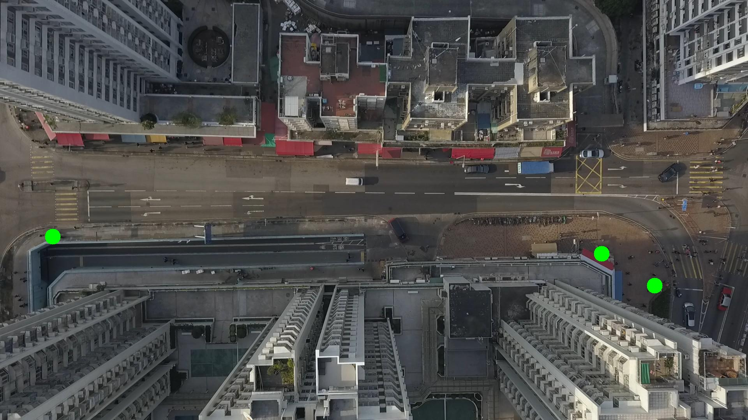

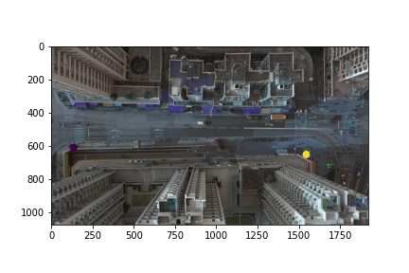

Silhouette metric for img015008.jpg is: 0.9975253858925233

Davies Bouldin metric for img015008.jpg is: 0.0032972421992396484

Calinski Harabasz metric for img015008.jpg is: 4082658.85743234

ID 0: (136, 608)

ID 1: (1680, 734)

ID 2: (1543, 652)

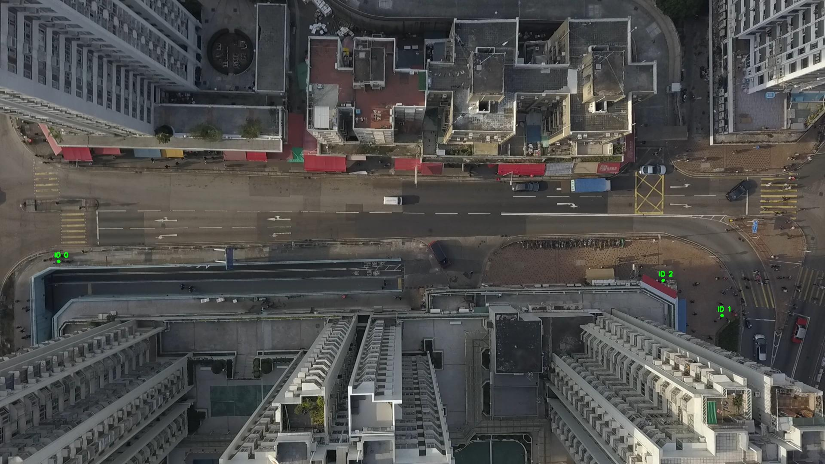

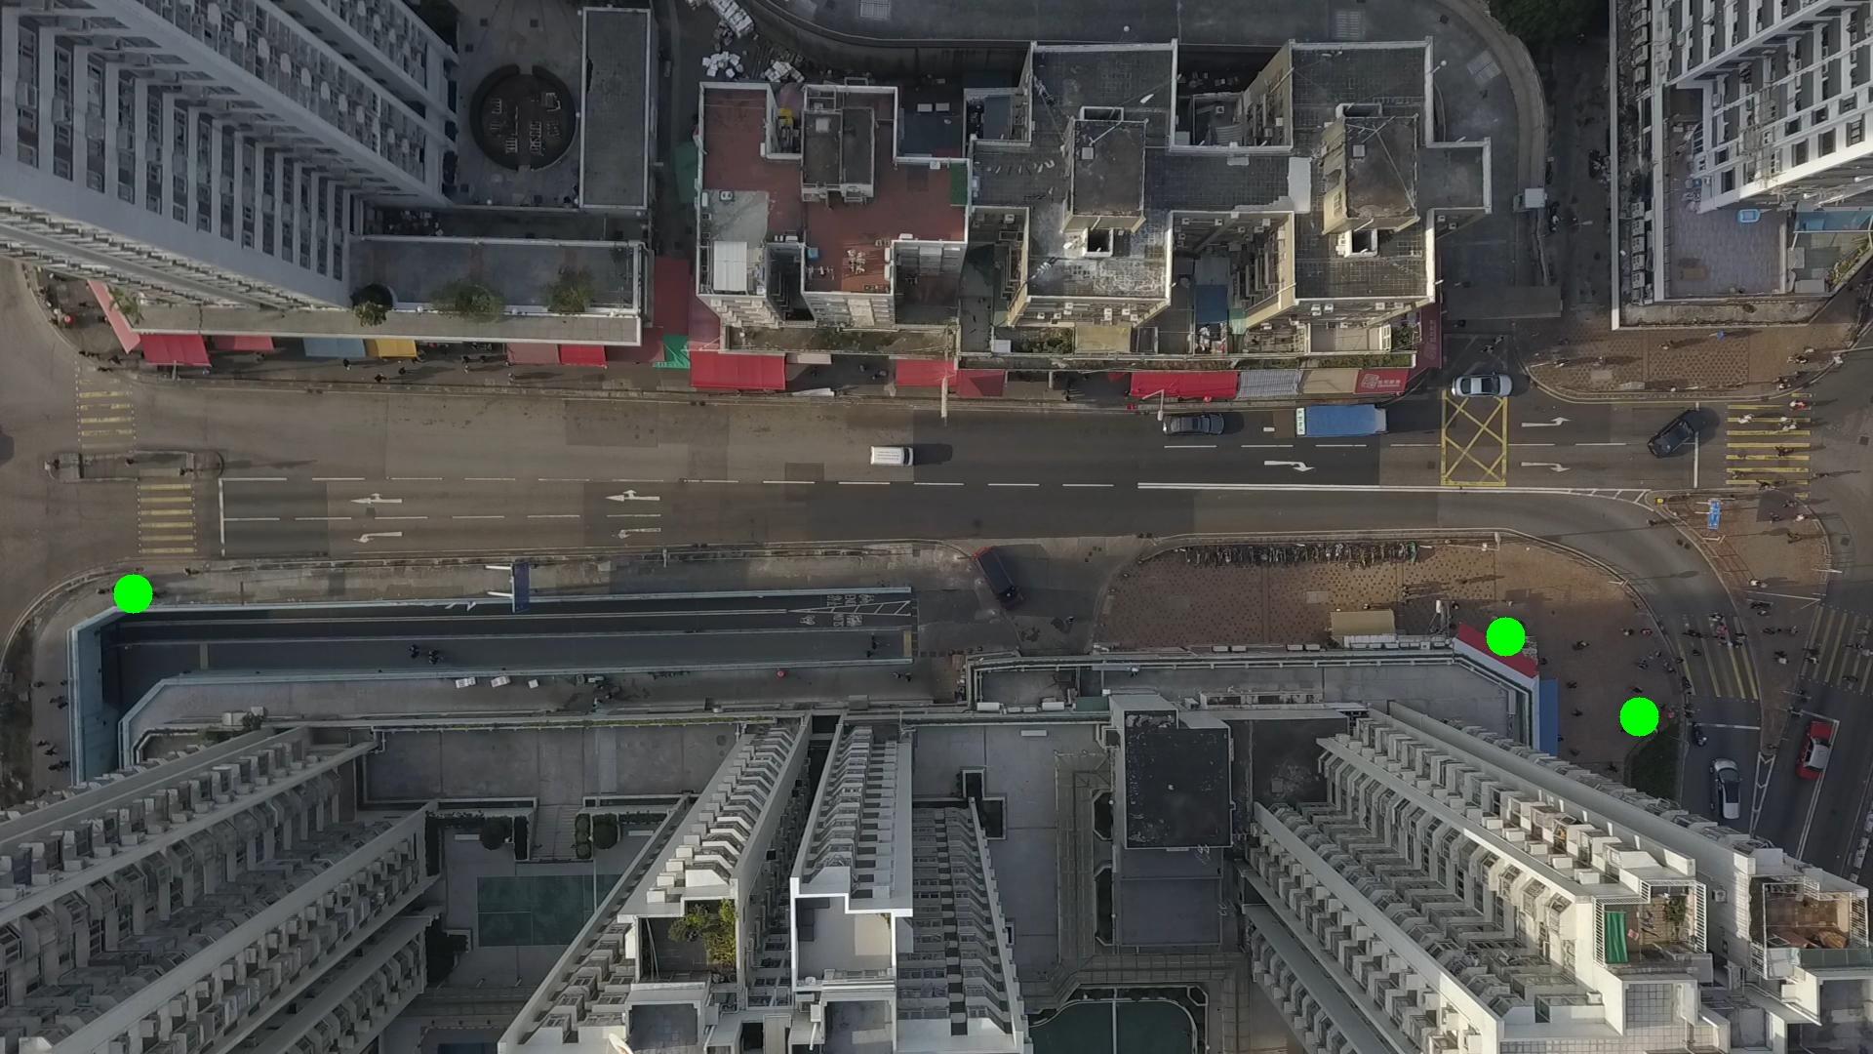

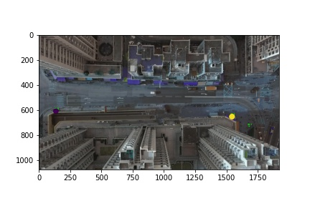

Silhouette metric for img015009.jpg is: 0.9814345454251734

Davies Bouldin metric for img015009.jpg is: 0.020618031091418715

Calinski Harabasz metric for img015009.jpg is: 31985.947305128702

ID 0: (136, 608)

ID 1: (1738, 650)

ID 2: (1544, 652)

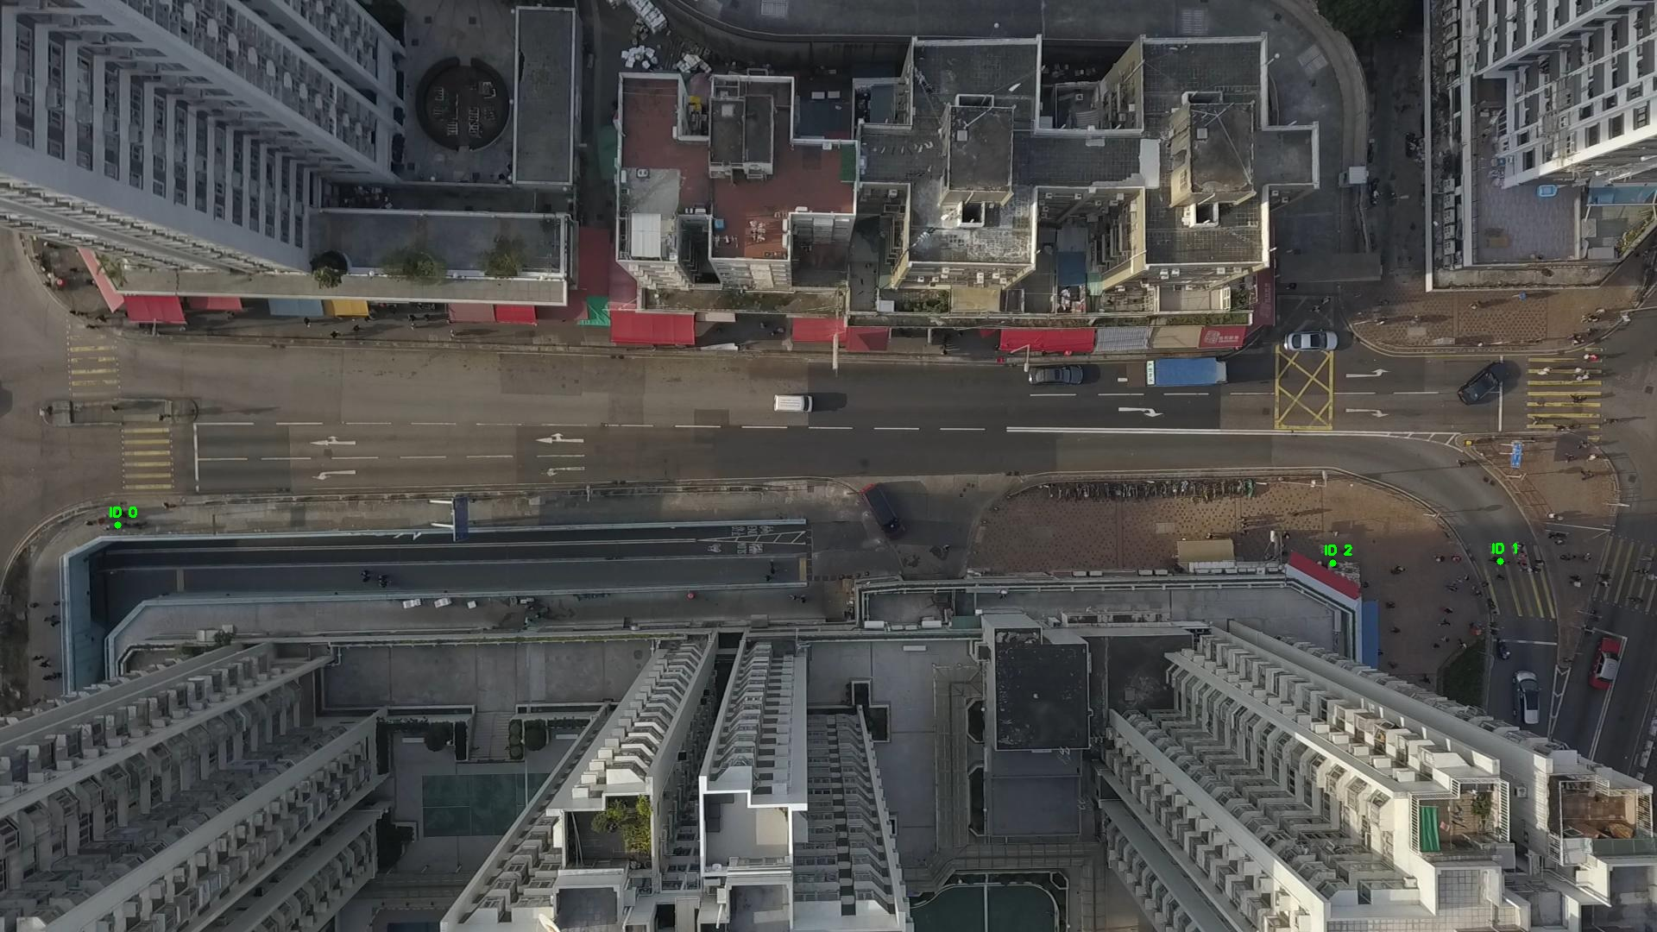

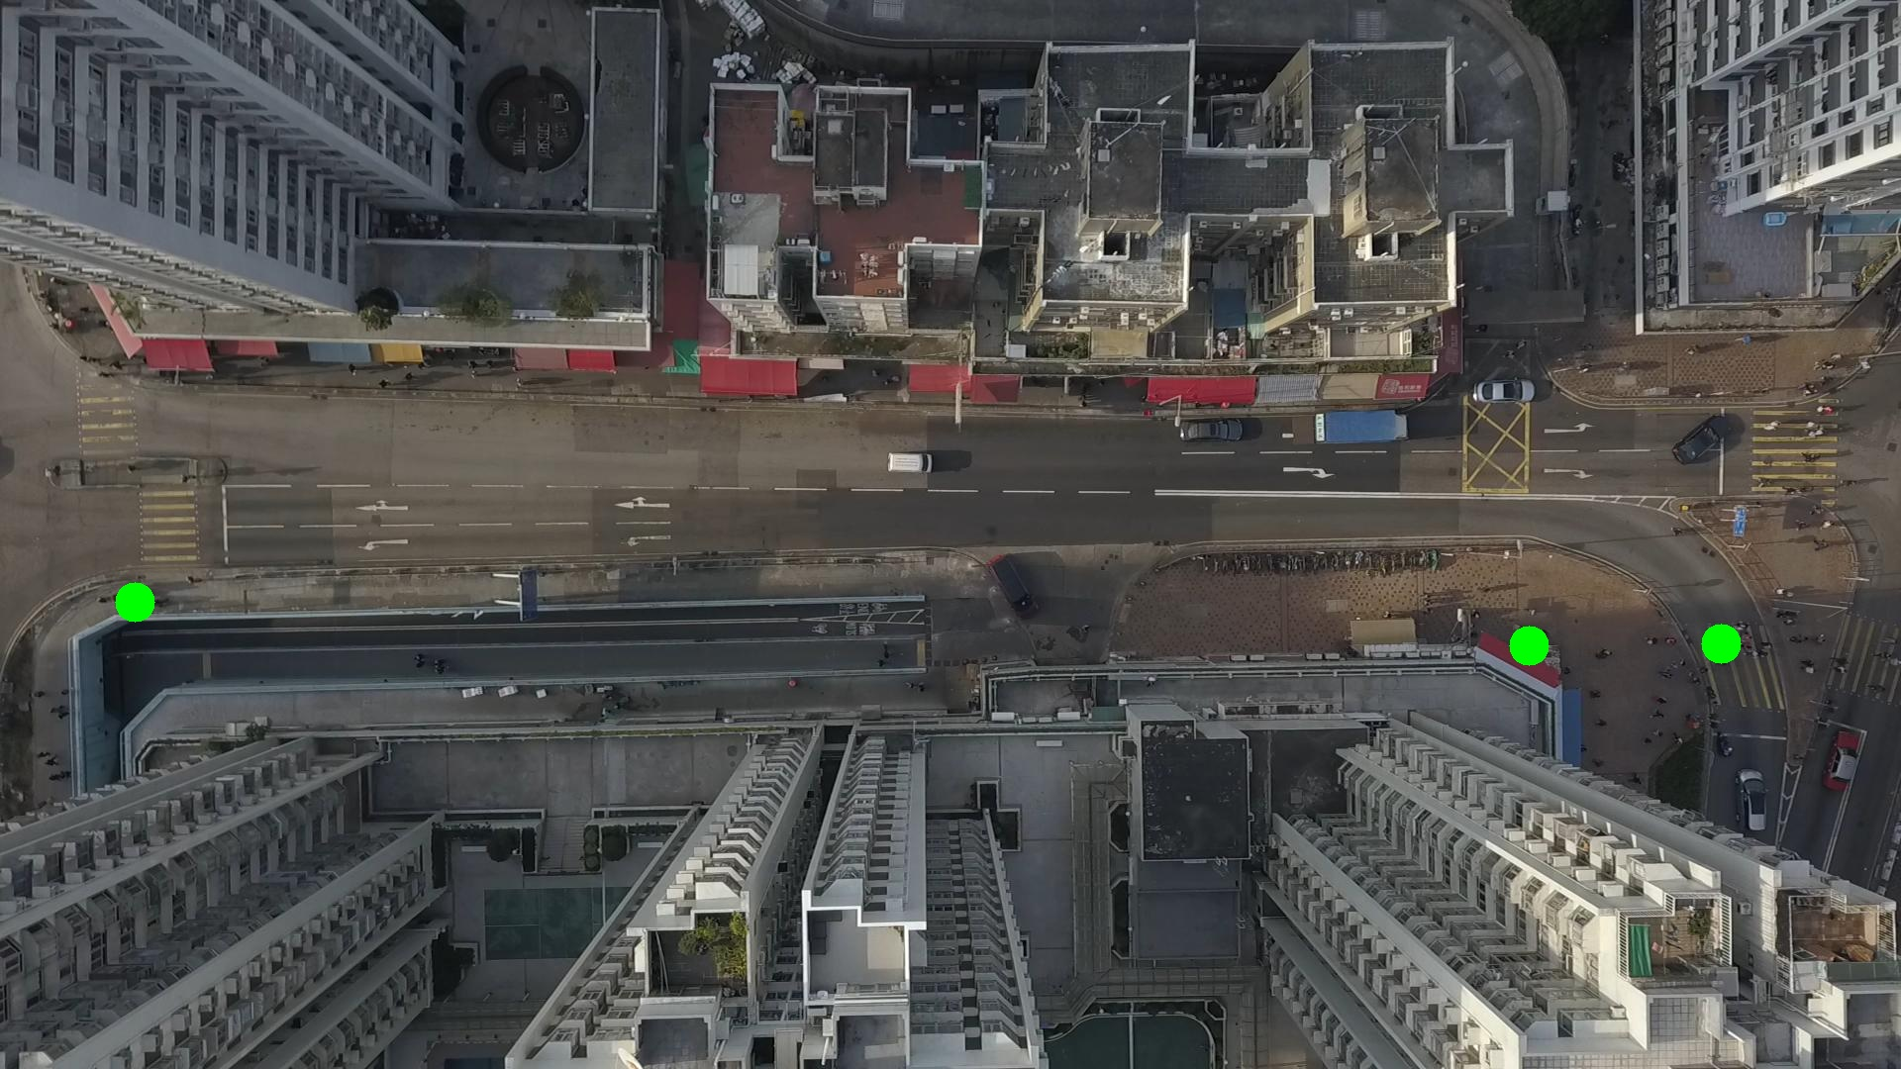

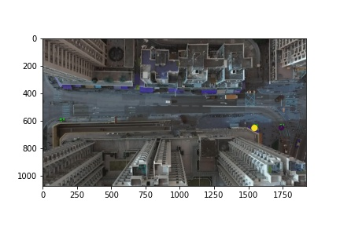

Silhouette metric for img015010.jpg is: 0.010321178385349123

Davies Bouldin metric for img015010.jpg is: 11.947030284985582

Calinski Harabasz metric for img015010.jpg is: 2.0877471208629372

ID 0: (1543, 651)

ID 1: (1738, 650)

ID 2: (1544, 653)

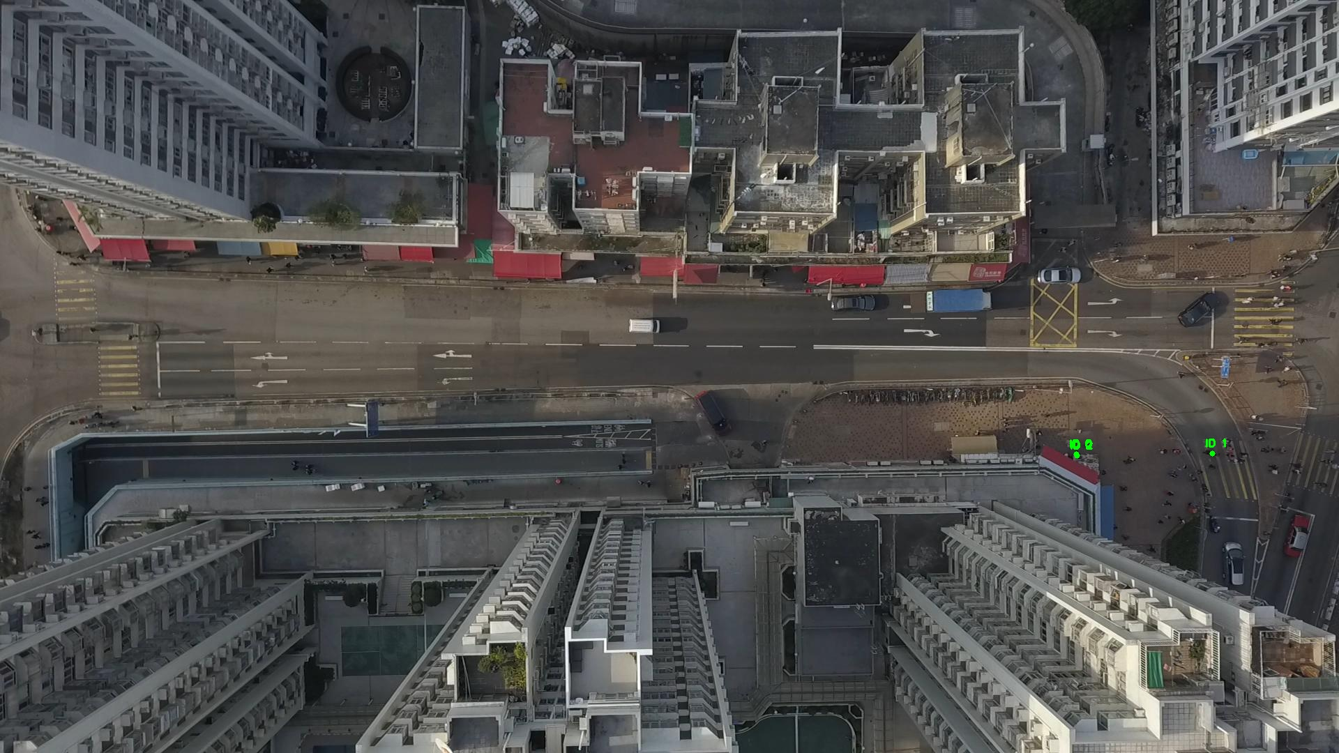

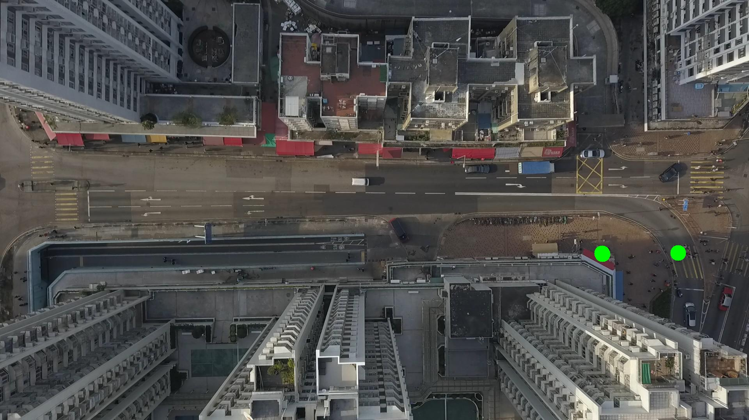

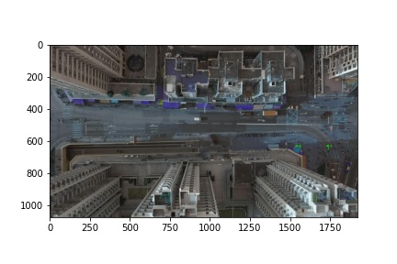

Silhouette metric for img015011.jpg is: 0.1089071213608421

Davies Bouldin metric for img015011.jpg is: 5.411774140514775

Calinski Harabasz metric for img015011.jpg is: 6.381726565056348

ID 0: (1543, 652)

ID 1: (1543, 650)

ID 2: (1543, 653)

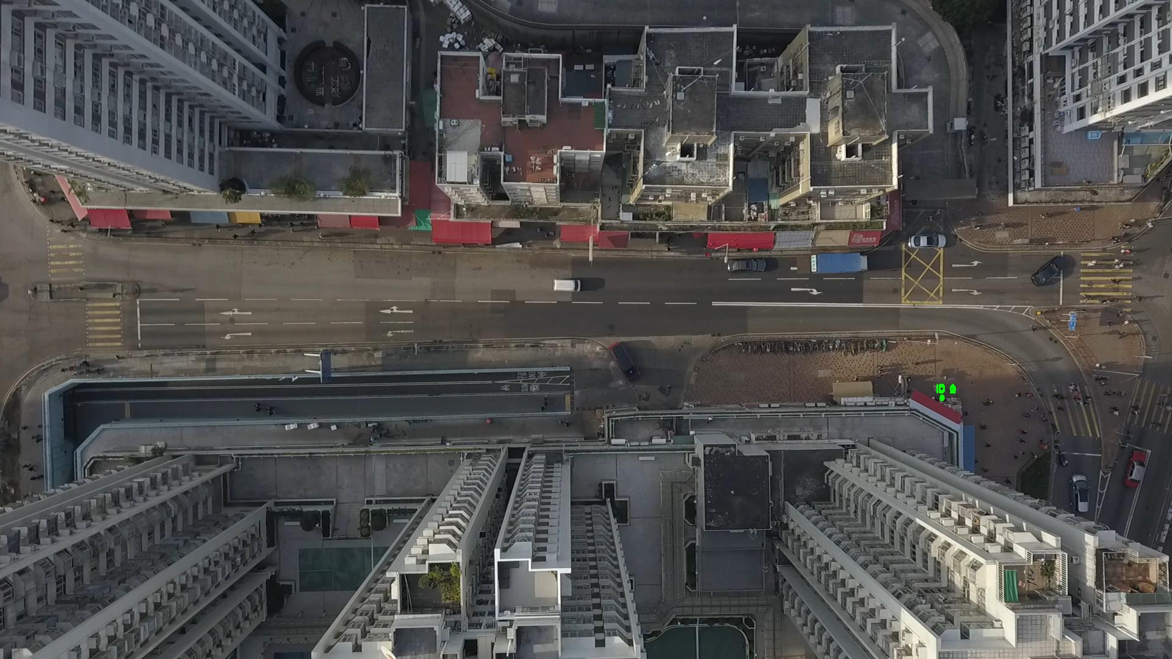

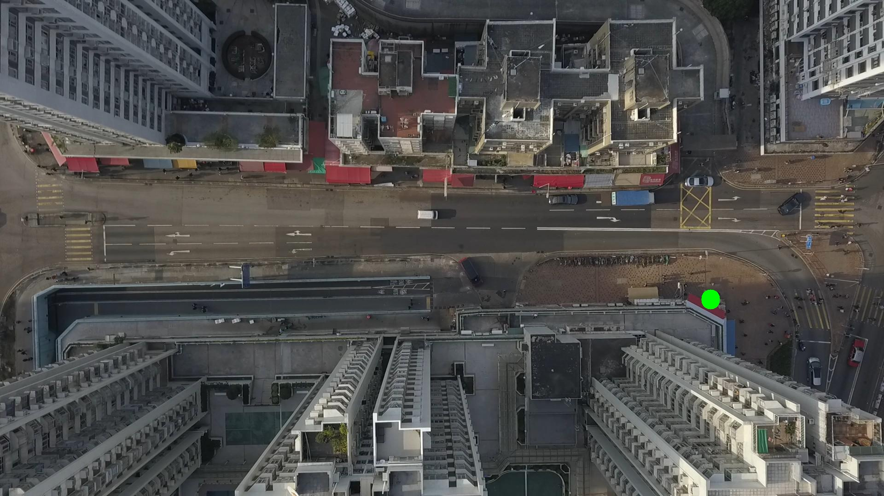

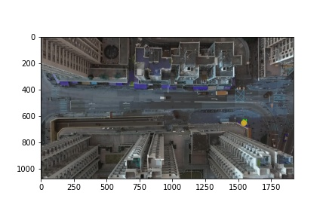

Silhouette metric for img015012.jpg is: 0.9974888761601414

Davies Bouldin metric for img015012.jpg is: 0.0029426629993581205

Calinski Harabasz metric for img015012.jpg is: 1758046.6463726778

ID 0: (1544, 652)

ID 1: (1543, 650)

ID 2: (1543, 653)

